21.99: a)
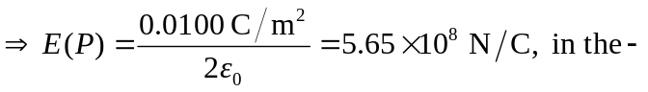x-direction.
b)
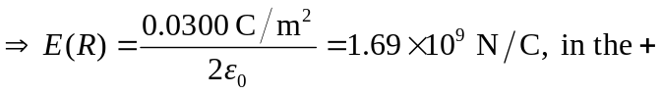x-direction.
c)
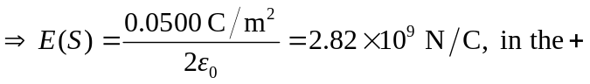x-direction.
d)
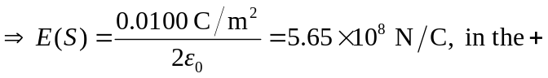x-direction.

